Please fill out one form per person
Ms |  | Mrs |  | Mr |  | Other (please specify)

Surname: |  | First Name:
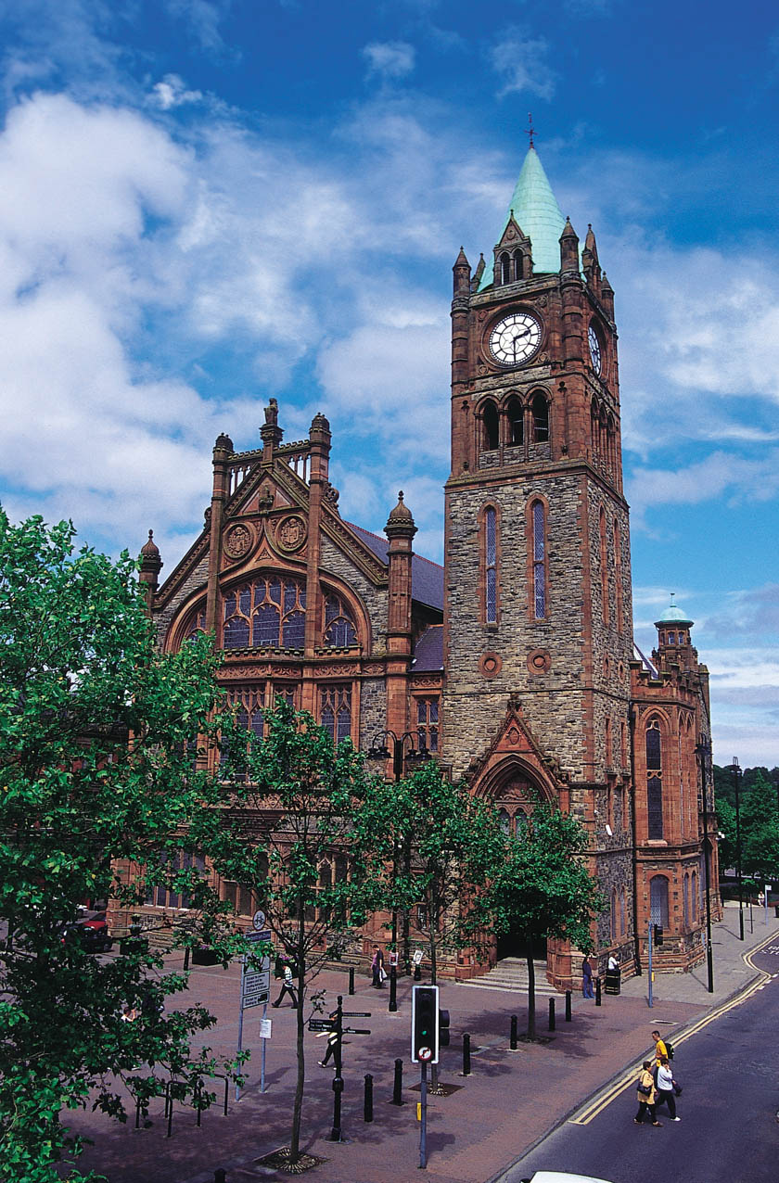
Organisation:

Position:

Address:

Postcode: |  | City:

Country:

Telephone: |  | Fax:

e-mail:

The partenariat will take place at the following address:
The Guildhall, Derry, Northern Ireland
Guildhall Square, Derry, BT48 6DQ
Telephone: Tel: +44 2871 377335
ACCOMMODATION
Participants must make their own reservations and pay their own accommodation costs. Block bookings for 50 rooms in total have been made at the following hotel:
- City Hotel Derry 4*,
Location: Queens Quay, Derry BT48 7AS
t. +44 2871 365800- f. +44 2871 365801
Web site: www.cityhotelderry.com
e-mail: reservations@cityhotelderry.com
Price per single room per night: £60 (incl. Breakfast)
Price per double room per night: £90 (incl. Breakfast)
Deadline for booking the hotel: April 4th
Reservation code: please quote: North P or Northern Periphery

MEALS
I will participate in the:
 | Lunch on day 1 |  | Dinner on day 1
 | Lunch on day 2 |  | Dinner on day 2
 | Lunch on day 3 |  | Vegetarian meals required
 |  |  | Special dietary requirements:
Please return the completed registration form by e-mail no later than Wednesday 4th April:
christopher.parker@npp2.net
When we have received your registration form. You will hear from us within a week. If you do not hear from us, please re-submit your registration.

If you have any further questions or require additional information, please contact Christopher Parker via e-mail or phone (+45 3283 3782).

When making this booking it will be considered as a final commitment from your side. Please inquire about the hotel’s cancellation policy when making the booking.

For more information about Derry City visit: www.derryvisitor.com

LANGUAGE
Please note that the partenariat will be held in English.

